A step-by-step guide to use the campaign file cleanser   
  
On Mac device:   
  
Note that at least Python 3 is already installed on your system just out of the box.   
Therefore, to be able to use the script ensure that you are using the updated version of pip.   
While using pip on the terminal, you can install almost everything you need.   
  
**Step 1:** Launch Terminal  
  
**Step 2:** ensure that you have the latest version of pip  
write on the terminal the following  
**python3 -m pip --version**  
  
you should see an output displaying the pip version, location, and the version of python   
  
pip 20.2.4 from /Users/shathaabduh/opt/anaconda3/lib/python3.8/site-packages/pip (python 3.8)  
  
Notice that pip3 is the updated version of pip that is used for python3+  
  
**Step 3:** write on the terminal the following command  
**python3 -m pip install --upgrade pip**  
the installation will be processed as seen below

**Step 4:** write down the following two commands to install the needed libraries.   
Pandas – for data analysis and manipulation tool.   
openpyxl – to read/write excel files   
  
**pip3 install pandas  
pip3 install openpyxl**   
  
the install will process unless if the libraries already exist in your system as seen in the screenshot below  
  
As the installation is complete. Now we are ready to run our script   
  
**Step 5:** change the directory to where the script and the campaign file exists   
  
*(Having the files on the desktop makes it easier to navigate and to delete the files when the campaign is executed)*   
  
when opening the terminal we are automatically placed in the username directory therefore you only need to write the following command line  
**cd desktop**   
  
if you are located in another directory then you need to type the following  
**cd ~/Desktop**  
  
  
**Step 6:** call the script file by typing the name of the file followed by .py   
**python3 modified.py**   
  
**Step 7:** Write down the description as they appear   
- file name (enter the base name without the extension)   
- extension code/country code   
- select the unit of the message body   
  
The executed files will appears on the located directory; in this case the desktop  
  
**You will get the following output files:**  
1. Info.txt : a file that contains a summary of   
- the number of duplicates   
- the number of empty rows   
- the total number of recipients numbers in respect of their digit count  
2. File name-correct#.xlsx (there could be multiple files in respect of the number of recipients in the input file and the unit of the body message)   
3. File name-wrong.xlsx: to check the numbers manually if necessary or to provide the client with the numbers that will be removed from the file before executing the campaign

On window device  
  
**Step 1:** download any python3+ executable installer by visiting the following link  
<https://www.python.org/downloads/windows/>  
  
  
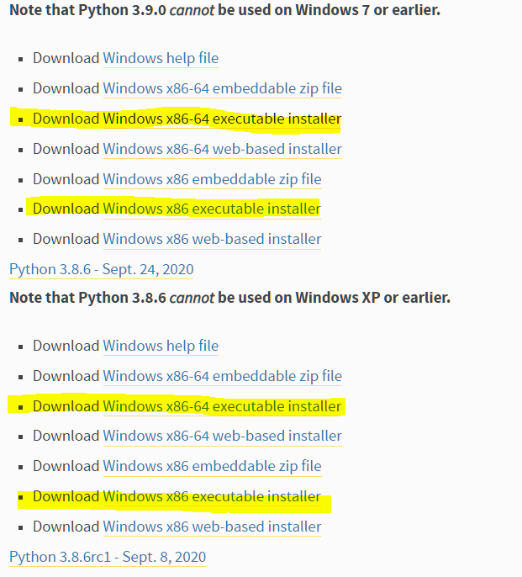  
  
  
**Step 2:** run executable installer once downloaded   
- make sure you select install launcher for all users and Add python 3.x to PATH  
- then select install now   
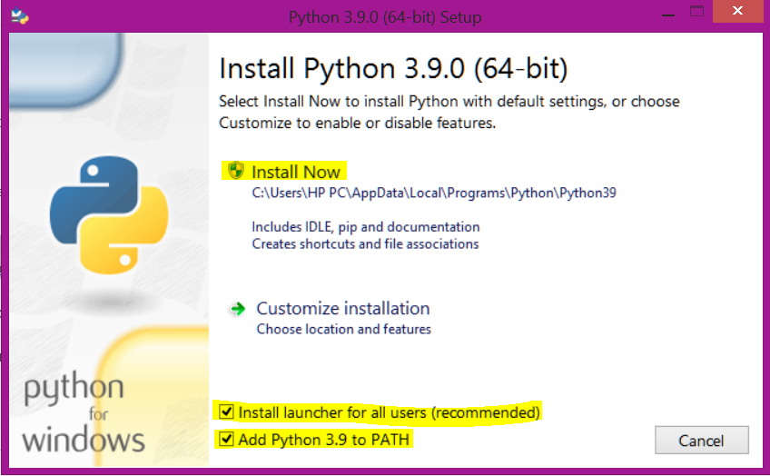  
  
  
Notice that for recent versions of python, the recommended installation option includes pip  
   
**Step 3:** Verify pip installation   
- open the command prompt application   
- type the following command   
**pip -V**  
  
you should see an output displaying the pip version, location, and the version of python  
  
pip 20.2.3 from c:\users\hp pc\appdata\local\programs\python\python39\lib\site-packages\pip (python 3.9)  
  
**Step 4:** Install the necessary libraries   
Pandas – for data analysis and manipulation tool.   
openpyxl – to read/write excel files   
  
- type the following command line   
**pip install pandas**  
  
  
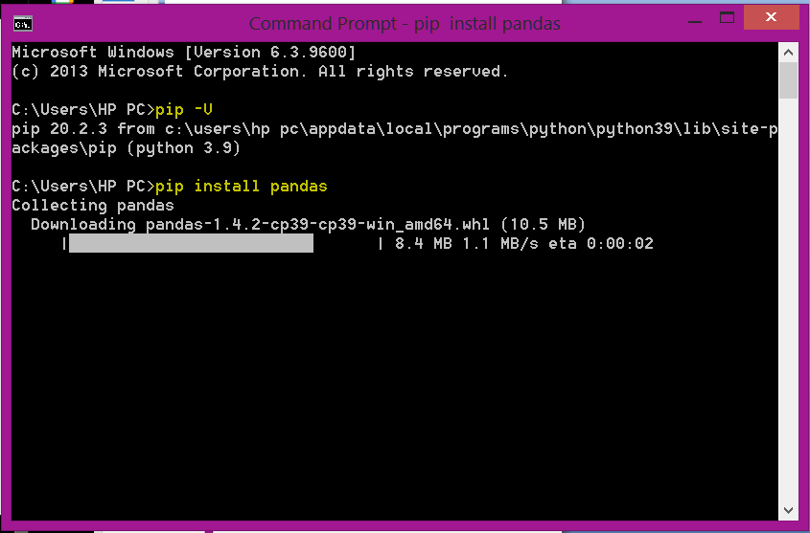  
  
- **pip install openpyxl**  
  
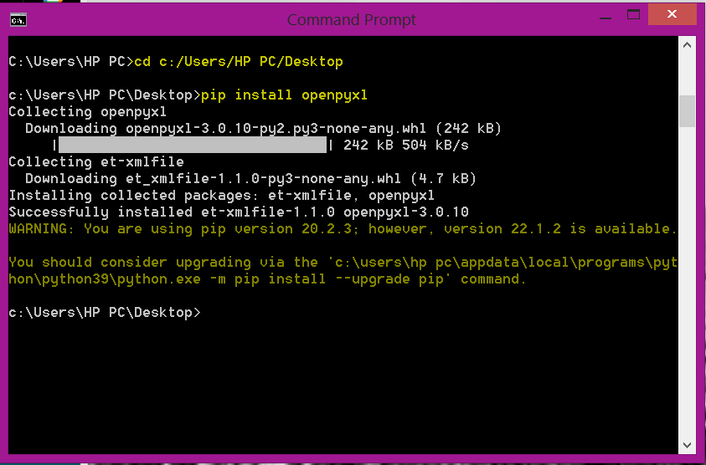

As the installation is complete. Now we are ready to run our script   
  
**Step 5:** change the directory to where the script and the campaign file exists   
  
*(Having the files on the desktop makes it easier to navigate and to delete the files when the campaign is executed)*   
  
when opening the terminal we are automatically placed in the username directory therefore you only need to write the following command line  
**cd desktop**   
  
if you are located in another directory then you need to type the following  
**cd c:\Users\(username)\Desktop**  
  
**Step 6:** call the script file by typing the name of the file followed by .py   
**python3 modified.py**   
  
**Step 7:** Write down the description as they appear   
- file name (enter the base name without the extension)   
- extension code/country code   
- select the unit of the message body  
 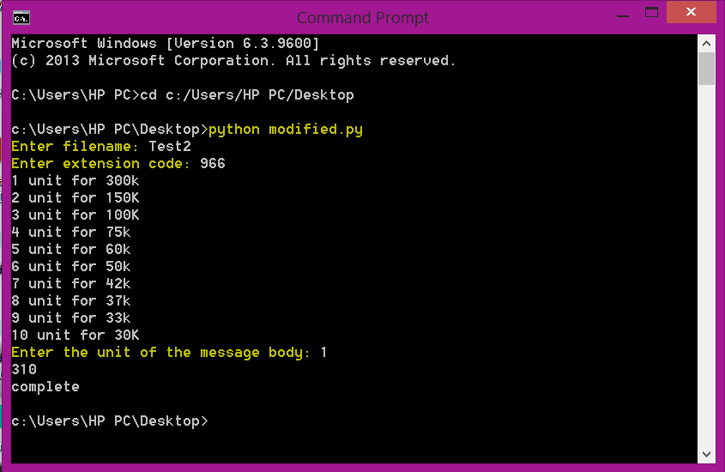  
  
The executed files will appears on the located directory; in this case the desktop  
  
you will get the following output files:  
1. Info.txt : a file that contains a summary of   
- the number of duplicates   
- the number of empty rows   
- the total number of recipients numbers in respect of their digit count  
2. File name-correct#.xlsx (there could be multiple files in respect of the number of recipients in the input file and the unit of the body message)   
3. File name-wrong.xlsx: to check the numbers manually if necessary or to provide the client with the numbers that will be removed from the file before executing the campaign